Lattice-Based Forward-Secure Data Communication in IoT with Signature-Based Trust Scoring

MINOR PROJECT REPORT
Submitted in partial fulfillment for the award of the degree of
BACHELOR OF TECHNOLOGY
(Department of Computer Science and Engineering)

Submitted to
INDIAN INSTITUTE OF INFORMATION TECHNOLOGY
BHOPAL (M.P.)

Submitted by
Jatin Rathore (23U02072)
Sathwik Krishna Kunapareddy (23U02145)
Mukund Mahakalkar (23U02045)
Jasvant Singh Dhaked (23U02054)

Under the supervision of
Dr. Saurabh Jain
Assistant Professor
Computer Science and Engineering
IIIT Bhopal

April, 2026
INDIAN INSTITUTE OF INFORMATION TECHNOLOGY
BHOPAL (M.P.)



CERTIFICATE

This is to certify that the work embodied in this report entitled “Forward Secure Lattice based encryption for IoT devices” has been satisfactorily completed by Jatin Rathore (23U02072), Sathwik Krishna Kunapareddy (23U02145), Mukund Mahakalkar (23U02045) and Jasvant Singh Dhaked (23U02054). It is a bonafide piece of work, carried out under our guidance in the Department of Computer Science and Engineering, Indian Institute of Information Technology, Bhopal for the partial fulfillment of the Bachelor of Engineering during the academic year 2025-26.

Date:29/04/2026

Dr. Saurabh Jain
Assistant Professor,
Computer Science and Engineering,
IIIT Bhopal (M.P.)
Dr. Rahul Chaurasia,
Minor Project Coordinator,
Computer Science and Engineering
IIIT Bhopal (M.P.)

INDIAN INSTITUTE OF INFORMATION TECHNOLOGY
BHOPAL (M.P.)


DECLARATION

We hereby declare that the following minor project synopsis entitled "Lattice-Based Forward-Secure Data Communication in IoT with Signature-Based Trust Scoring" presented in the is the partial fulfillment of the requirements for the award of the degree of Bachelor of Technology in Computer Science and Engineering. It is an authentic documentation of our original work carried out under the able guidance of Dr. Saurabh Jain. The work has been carried out entirely at the Indian Institute of Information Technology, Bhopal. The project work presented has not been submitted in part or whole to award any degree or professional diploma in any other institute or organization.

We, with this, declare that the facts mentioned above are true to the best of our knowledge. In case of any unlikely discrepancy that may occur, we will be the ones to take responsibility.

Jatin Rathore (23U02072)
Sathwik Krishna Kunapareddy (23U02145)
Mukund Mahakalkar (23U02045)
Jasvant Singh Dhaked (23U02054)
ACKNOWLEDGEMENT

We, by Jatin Rathore, Sathwik Krishna Kunapareddy, Mukund Mahakalkar and Jasvant Singh Dhaked like to express our sincere gratitude to everyone who supported and guided us throughout the successful completion of our minor project titled "Lattice-Based Forward-Secure Data Communication in IoT with Signature-Based Trust Scoring".

First and foremost, we would like to extend our heartfelt thanks to our esteemed Director, Prof. Ashutosh Kumar Singh, for providing us with the necessary resources and facilities for conducting our project. His/her encouragement and vision played a key role in helping us accomplish our goals.

We are deeply grateful to our Dr. Saurabh Jain, for his/her constant guidance, invaluable suggestions, and expert advice throughout the project. His/her knowledge and insights helped us enhance the quality of our work, and his/her support kept us motivated during difficult times.

Our sincere thanks to Dr. Rahul Chaurasia, for organizing and overseeing the entire project process. His/her assistance in clarifying doubts and providing us with the right direction was instrumental in the smooth execution of our project.

We would also like to express our gratitude to all the faculties of the Computer Science and Engineering for their continuous support and encouragement. Their teaching and knowledge were invaluable in enhancing our technical skills and understanding, which helped us in the successful completion of the project.

A special thanks to our friends for their continuous support, valuable suggestions, and helping us during various stages of the project. Their insights and encouragement motivated us to keep working on the project with enthusiasm.

Last but certainly not the least, we would like to express our deepest gratitude to our parents and family members for their love, patience, and continuous moral support throughout the course of this project. Their understanding and encouragement were the driving force behind our efforts.

We are truly thankful to everyone who directly or indirectly contributed to the success of this project. Without their assistance and support, this project would not have been possible.

Jatin Rathore (23U02072)
Sathwik Krishna Kunapareddy (23U02145)
Mukund Mahakalkar (23U02045)
Jasvant Singh Dhaked (23U02054)
AREA OF WORK

Our project will mainly focus on POST-QUANTUM CRYPTOGRAPHY and IOT SECURITY using a set of lattice-based mathematical frameworks and technologies that are required for the long-term protection of resource-constrained networks.
While one may argue that the same data protection could be achieved using standard encryption algorithms like RSA or ECC, that’s where the real catch is. As it is already established, conventional cryptography is highly vulnerable to upcoming quantum computing attacks (specifically Shor's algorithm), and because IoT devices often have lifecycles spanning 10 to 20 years, data encrypted today must remain unbreakable well into the quantum era.
It’s been a fairly long period since we started relying on traditional public-key infrastructure to secure digital communications. However, in the past decade, the rapid advancement toward practical quantum computers alongside the explosive growth of interconnected edge devices has posed a serious challenge for cybersecurity. That's where post-quantum cryptography came in, and with time we also realized the need to protect against physical device capture (requiring forward secrecy [1]) without relying on heavy certificate management—and ever since the recent NIST [2] standardizations, the urgency to migrate just keeps growing bigger and bigger.
In our project, we’ll be looking at the architecture of a forward-secure, lattice-based Identity-Based Encryption (IBE) [3] [4] pipeline. We’ll also look at the dynamic gating and analysis of network requests using a Dilithium-3 [5] signature-based trust verification model.
TABLE OF CONTENT

S.no | Title | Page No.
 | Certificate | i
 | Declaration | ii
 | Acknowledgement | iii
 | Area of Work | iv
 | List of Figures | v
 | List of Tables | vi
 | Abstract | vii
1 | Introduction | 1
1.1 | The Quantum Threat to IoT | 1
1.2 | Overcoming IoT Limitations with Advanced Cryptography | 1
1.3 | Project Motivation and Scope | 2
2 | Literature Review | 3
2.1 | Evolution of Identity-Based Encryption | 3
2.2 | Lattice-Based Cryptographic Constructions | 3
2.3 | Forward Secrecy and Key Evolution | 4
2.4 | Access Control and Trust Management in IoT | 7
2.5 | Post-Quantum Signatures for Authentication | 8
2.6 | Research Gap | 8
3 | Problem Definition and Objectives | 9
3.1 | Problem Statement | 9
3.2 | Technical Challenges | 9
3.3 | Objective | 10
4 | Proposed Methodology and Work Description | 11
4.1 | System Architecture Overview | 11
4.2 | Core System Components | 11
4.3 | Step-by-Step System Flow and Work Description | 12
5 | Implementation (Tools and Technology Used) | 16
5.1 | Programming Language and Core Libraries | 16
5.2 | Development and Design Environments | 16
5.3 | Implemented Cryptographic Schemes | 17
5.4 | Comparative Benchmarking Baselines | 17
6 | Proposed Algorithm | 18
6.1 | Algorithm 1: Trapdoor Generation (TrapGen) | 18
6.2 | Algorithm 2: Preimage Sampling (SamplePre) | 19
6.3 | Algorithm 3: Minimal Cover (MinCov) | 19
6.4 | Algorithm 4: Forward Secrecy Key Update (Update) | 20
6.5 | Algorithm 5: Dual Regev Data Encryption (Encrypt) | 20
6.6 | Algorithm 6: Dual Regev Data Decryption (Decrypt) | 21
7 | Result Discussion and Analysis | 22
7.1 | Parameter-Level Performance Comparison | 22
7.2 | Performance Metrics by Device Count | 25
7.3 | Batch Processing Metrics (seconds) | 24
7.4 | Summary Table | 27
8 | Conclusion and Future Scope | 30
9 | References | 31

LIST OF FIGURES

Fig | Description | Page no.
1 | Proposed Framework | 14
2 | Proposed Sequence diagram of IoT Device Forward Secure Communication with Trust Verification | 15
3 | Data Encryption Time Across Security Levels | 24
4 | Overall Latency Across Security Levels | 24
5 | Overall Throughput Across Security Levels | 24
6 | Authentication Latency vs Device Count | 26
7 | Computation Cost vs Device Count | 26
8 | Throughput vs Device | 27
9 | Normalized Throughput vs Device Count | 27
10 | Batch Formation Time | 28
11 | Decryption Time (log scale) | 28
12 | Batch Authentication Time | 28
13 | Overall Performance Radar Chart | 28

LIST OF TABLES

Table No | Description | Page no.
1 | Literature Review | 3
2 | Comparison with SOTA scheme | 20
3 | Cryptographic Operation Times and Throughput at PARA.512 | 23
4 | Cryptographic Operation Times and Throughput at PARA.768 | 23
5 | Cryptographic Operation Times and Throughput at PARA.1024 | 23
6 | Authentication Latency | 25
7 | Computation Cost | 25
8 | Throughput | 25
9 | Verified Normalized Throughput | 25
10 | Storage Overhead | 26
11 | Batch Formation | 27
12 | Batch Decryption Time | 27
13 | Batch Authentication Time | 28
14 | Overall Scheme Evaluation and Trade-off Analysis | 29

ABSTRACT

Billions of smart devices are now part of everyday infrastructure through the Internet of Things, but the cryptographic protections guarding these networks are not designed with quantum-level threats in mind. Trusted algorithms such as RSA and ECC [6][7] that are the foundation of digital security for years become vulnerable against Shor's algorithm [2] running on sufficiently powerful quantum machines. This problem becomes even worse for IoT devices for two reasons: they tend to stay deployed for years, sometimes even decades, and they are often placed in physically accessible spots where someone could extract the stored keys without much difficulty.

This project addresses that gap by proposing a post-quantum framework for secure data sharing, built around Forward-Secure Lattice-Based Identity-Based Encryption (IBE) [3][4]. At its cryptographic core lies the Learning with Errors (LWE) [8] problem, which is a hardness assumption rooted in lattice mathematics. So far, no quantum algorithm has been shown to crack it efficiently. Since this scheme follows an identity-based model, a device's own identifier like a serial number or MAC address serves as its public key. This removes the need for certificate management entirely, as for hardware-constrained devices this traditional PKI scales poorly.

This framework differs from earlier lattice-based approaches in how it deals with key compromise scenarios. Forward secrecy [1] is baked into the design through a binary-tree based key evolution mechanism. Cryptographic keys progress through a tree structure at every epoch, and previous key gets permanently erased. The practical effect is that even if an attacker gets hold of a device physically today, all the ciphertexts from past epochs stays mathematically unreachable. Additionally we deployed a trust management layer powered by Dilithium-3 [5] digital signatures. Each data query gets signed and verified in real time. A dynamic scoring system keeps track of how each node behaves. This credits legitimate activity and gradually cuts off nodes whose requests keeps failing verification.

Testing across NIST [2] security levels 1, 3, and 5 showed consistent outcomes. The False Trust Acceptance Rate came out at 0% across every configuration tested, and authentication latency stayed consistently within the 50 to 70 millisecond range. These figures show that this system isn't only theoretical but also practically applicable and quick enough for real-time IoT tasks and secure enough to justify using in settings where devices need to stay trustworthy over many years.

- Introduction

Smart meters that monitor how much electricity a house is using, wearable health sensors keeping tabs on a patient's vital signs, industrial controllers running entire factory floors billions of such devices now make up what we call the Internet of Things. These gadgets don't stop at just collecting data. They generate it, transmit it, and store it continuously, and most of the time there is very little human oversight involved. For the majority of the IoT's lifespan, RSA, Elliptic Curve Cryptography (ECC), and AES have done a decent enough job for protecting this information. They were built for classical computers, performed reliably. But that foundation is starting to crack.
1.1 The Quantum Threat to IoT
Quantum computing has become a genuine engineering pursuit with a fairly clear timeline. Once fault-tolerant quantum machines reach adequate scale, Shor's algorithm will have the ability to break apart the mathematical problems on which RSA and ECC [6] [7] are built - specifically integer factorization and discrete logarithm problems and it can do so in polynomial time. For conventional computing systems, this represents a serious but handleable transition. You upgrade your algorithms, rotate your keys, and move forward. But for IoT this is a bigger problem.

IoT devices don't get replaced on regular software update cycles. They get bolted onto walls, embedded inside pipelines, sometimes even implanted in patients. A lot of them will keep running for ten to twenty years without major changes. Data that these devices encrypt today needs to still be confidential a decade later, but the encryption scheme protecting it might already be crackable by then. This is referred to as the "harvest now, decrypt later" problem, and IoT networks is in the middle of it. The urgency of this was acknowledged by NIST [2] when they finalized post-quantum cryptography standards back in 2024. This became a signal that the window for migrating isn't long.

1.2 Overcoming IoT Limitations with Advanced Cryptography
The quantum vulnerability is only one part. IoT devices also has to work under constraints that most other computing platforms don't face: very tight power budgets, limited storage capacity onboard, and physical exposure at the level of theft or tampering. There is no single cryptographic technique that can handle all these issues at once. The framework we designed combines several different approaches together.

Identity-Based Encryption (IBE) [3] [4]: With standard public key infrastructure, every device has to get a digital certificate, store it, and periodically renew it. This scales terribly when you have thousands of low-power nodes trying to participate. IBE avoids all of that completely. A device's own identifier its serial number, its MAC address, any unique string the network already recognizes becomes its public key. No certificates needed, no renewal, and no bottlenecks from certificate authorities.

Post-Quantum Lattice Security: The actual encryption is constructed on top of the Learning with Errors (LWE) [8] problem. This is a mathematical challenge from lattice theory, and despite many years of active research by the cryptography community, nobody has found a quantum algorithm that solves it efficiently. This gives the system a reasonable claim to long-term resilience against both classical and quantum-era attackers.

Forward Secrecy [1]: When a device gets stolen, whoever took it gains access to whatever keys happens to be stored on it at that moment. Forward secrecy makes sure that this kind of exposure has a hard time boundary. Using a binary-tree key evolution approach, the system moves its keys forward at regular intervals and deletes the old ones in a way that can't be reversed. Any ciphertexts from the past, even if captured during transmission, stays permanently locked away.

Trust Verification via Dilithium-3 [5]: Not all threats originate from outside the network. Sometimes compromised or malicious nodes try to get data by submitting fake queries. The framework handles this by mandating that every single data request carries a Dilithium-3 [5] signature. This is a post-quantum scheme that NIST [2] has standardized. A dynamic trust evaluation mechanism monitors how each node act over time. Nodes that consistently behave properly retain their access. Those that don't get progressively cut off.

1.3 Project Motivation and Scope
The Identity-Based Encryption schemes available right now don't offer forward security. The forward-secure schemes that do exist are all built on classical hardness assumptions that quantum computers will eventually break. And there hasn't been any prior work that successfully combines lattice-based IBE with forward secrecy and cryptographic trust management into one unified system that is specifically built for IoT environments.

This project was driven by exactly that gap. Instead of treating quantum resistance, key evolution, and trust management as three isolated research questions, the approach taken here merges them into a single coherent architecture. The objective is to create a system where every component supports the other. Encryption that is quantum-safe, keys that self-destruct according to schedule, and a network that continuously verifies whether the entities asking for data actually deserve to have access. The design is aimed at IoT deployments to remain secure and trustworthy across lifespans measured in years rather than months.

- Literature Review

Research into secure data-sharing for IoT hasn't stopped. Over the last two decades, the research community has been moving with caution and sometimes with real urgency away from the classical public-key constructions. Initially, the push was practical in nature. Managing certificates became too cumbersome for devices with limited resources. But the stronger concern has been the quantum threat. The cryptographic algorithms that billions of devices presently rely on will not hold up once large-scale quantum hardware becomes a reality. The following is a review of the major developments that have shaped this area and the gaps that still remain.

2.1 Evolution of Identity-Based Encryption
Back in 1984, Shamir's paper [3] introduced the concept of Identity-Based Encryption through a beautifully simple idea: take the recipient's identity could be their name, email address, or really any publicly known string and use it directly as the public key. This would eliminate the whole certificate infrastructure problem. It was a really compelling concept, but there wasn’t a working practical construction behind it for close to two decades.

That changed in 2001 when Boneh and Franklin [4] proposed their scheme using bilinear pairings over elliptic curves and relied on the Bilinear Diffie-Hellman assumption. It was the first IBE system that genuinely worked in practice. It was efficient, mathematically elegant, and it kicked off a whole wave of follow-up research. Later, Waters in 2005 [11] took the theoretical underpinnings further by constructing IBE schemes that didn't depend on the random oracle model which is a mathematical abstraction that is an imperfect substitute for how hash functions actually behave in the real world [24].

Despite all these important contributions, every single one of these constructions share a critical weakness when considered from a post-quantum perspective. The bilinear pairing problems at their foundation can be broken by Shor's algorithm. A quantum computer with enough capability to run Shor efficiently would completely compromise these schemes. For IoT devices that are expected to keep operating for a decade or more, that timeline isn’t safe.

2.2 Lattice-Based Cryptographic Constructions
Cryptography based on lattices [21] has emerged as probably the most believable defense against quantum computing threats. The fundamental problems it depends on Learning with Errors being the most prominent one don't seem to give way to quantum algorithms in the same manner that factoring and discrete logarithm problems do. There are formal mathematical reductions connecting the average-case difficulty of LWE to the worst-case hardness of well-known lattice problems, which provides a solid theoretical foundation [21].

It was Regev in 2009 [8] who established this connection with proper rigor, giving cryptographers the sort of theoretical assurance they need before they commit to adopting a new hardness assumption. The practical breakthrough followed from Gentry, Peikert, and Vaikuntanathan in 2008 [12], who developed the TrapGen and SamplePre primitives. These are tools for creating lattice trapdoors and sampling preimages, and they made it actually feasible to construct lattice-based IBE. Micciancio and Peikert in 2012 [9] later refined these trapdoor techniques to improve efficiency further. Waters in 2009 [17] also made a significant contribution with the Dual Regev framework, which enabled fully secure IBE under standard assumptions and without needing random oracles.

Although it looks solid theoretically, practically it is complicated for IoT. Keys generated from lattice-based schemes are considerably larger compared to their classical equivalents. You also have to carefully manage ciphertext noise or you risk decryption failures. The matrix computations at the core of these algorithms, while polynomial-time in theory, aren't cheap when you're running them on a tiny sensor node powered by a coin-cell battery. These are engineering hurdles, but they definitely require careful attention in any design targeting IoT.

2.3 Forward Secrecy and Key Evolution
Stealing an IoT device happens routinely in practice. Sensors deployed in remote outdoor locations, medical devices sitting in easily accessible hospital rooms, or industrial controllers in facilities where physical security is limited. All of these present realistic targets for someone willing to physically grab a device and read what's in its memory. Forward secrecy is the cryptographic property that limits the damage from such incidents. Even if an attacker gets full access to a device's current key material, they learn absolutely nothing about any data that was encrypted during previous time periods.

Canetti, Halevi, and Katz gave this concept a rigorous formal treatment using binary-tree key evolution [1]. The basic idea is that a device's secret key doesn't stay the same forever. Instead it moves through nodes of a binary tree, and each time it transitions, the previous version gets erased permanently without a way to recover it. Boyen, Chu, and Waters in 2006 [14] improved on this with delegation-based key updates. When translated into the lattice setting, the mechanism relies on trapdoor-based preimage sampling to evolve keys locally on the device, eliminating need of contacting a central server every time a new epoch begins.

The most recent lattice-based contribution in this direction comes from Jin et al. in 2024 [18]. They proposed a forward-secure IBE scheme designed with IoT in mind, which is a meaningful step ahead. But there still exists scalability concern. Both the secret key sizes and the ciphertext sizes in their scheme grows logarithmically as the number of time periods increases. That kind of growth rate can become a real limiting factor when considering the constraints of IoT devices.

2.4 Access Control and Trust Management in IoT
Encryption does a good job of protecting data while it's being transmitted or while it is stored somewhere, but it tells nothing about whether the entity requesting that data should be allowed to access it. That's where access control and trust management come into play. And in IoT environments where devices can be compromised, spoofed, or sometimes just malfunctioning on their own these mechanisms are absolutely not optional.

Roman et al. in 2013 [6] along with Zhao and Ge also in 2013 [7] documented what IoT authentication looked like at that point in time. They found weak identity verification practices, no good way to evaluate trust at scale, and authentication mechanisms that seemed like they were added as an afterthought rather than being part of the original design. Chen et al. in 2019 [15] brought lattice-based access control into the conversation, but their scheme doesn't include forward secrecy or any kind of dynamic trust assessment. Huang et al. in 2025 [19] addressed some of the key management overhead issues with a revocable IBE approach, but backward secrecy and real-time behavioral monitoring are both missing from what they proposed.

The bigger issue is an architectural one. In almost all of the existing research, encryption and access control get treated as two separate subsystems that are bolted together after the fact rather than being designed as a unified whole from the start. This creates a problematic blind spot. A node can possess perfectly valid cryptographic credentials and still act maliciously maybe flooding the network with pointless queries, maybe extracting data it has absolutely no legitimate reason to access and the system has no built-in way to detect or respond to this behavior [25] [26].

2.5 Post-Quantum Signatures for Authentication
Ensuring data integrity and confirming that requests are authentic represent the other half of the security equation. CRYSTALS-Dilithium, which was proposed by Ducas et al. in 2018 [5] and later standardized by NIST, has become the leading practical option for post-quantum digital signatures. Its security is grounded in Module-LWE and Module-SIS assumptions, which belong to the same lattice-based family that supports the encryption side of things. It manages to achieve a reasonable trade-off between keeping signatures compact and maintaining fast verification speeds.
The problem now is how current frameworks incorporate it, or more accurately, how they fail to incorporate it properly. In most IBE-based systems [28], digital signatures get handled as a separate verification step that runs independently from the encryption pipeline. Authentication is done in one place and confidentiality is checked in another place. This fragmented security model has critical weak points that become a target to adverseries.

2.6 Research Gap
From this review, we find a collection of gaps that have each been individually recognized but collectively remain unaddressed. No existing system manages to bring lattice-based IBE, forward secrecy, and trust-aware access control together within a single integrated framework. The ability to evaluate trust at the query level, meaning assessing whether a node is legitimate not just once during registration but on every single request it makes is largely absent from current proposals. Quite a few schemes continue to rely on cryptographic primitives that have known vulnerabilities to quantum attacks. Key management architectures in many designs lean heavily on centralized authorities, creating single points of failure in networks that are supposed to be distributed by nature. The scalability problems caused by growing key sizes and ciphertext sizes are a challenge for forward-secure constructions that need to run on hardware with very limited resources. To provide a clearer comparison of the discussed approaches, table 1 summarizes their key contributions, methodologies, and limitations.

Table 1: Summary of Literature Review
S.No | Article | Journal/ Conf. | Methodology | Outcomes/ Limitations
1 | Identity-Based Cryptosystems and Signature Schemes – Shamir [3] | CRYPTO (1984) | Introduces identity as public key eliminating certificate requirement | Removes PKI overhead; lacks practical construction
2 | Identity-Based Encryption from the Weil Pairing – Boneh & Franklin [4] | CRYPTO (2001) | Uses bilinear pairings and BDH assumption for encryption | First practical IBE; vulnerable to quantum attacks
3 | Efficient Identity-Based Encryption without Random Oracles – Waters [11] | EUROCRYPT (2005) | Constructs IBE in standard model without random oracle | Stronger security; higher computational cost
4 | Identity-Based Encryption using Quadratic Residues – Cocks [10] | IMA Conf. (2001) | Uses quadratic residuosity assumption instead of pairings | No pairing required; large ciphertext size
5 | On Lattices, Learning with Errors, and Cryptography – Regev [8] | JACM (2009) | Defines LWE with worst-case hardness reduction | Foundation of PQ crypto; computational overhead
6 | Trapdoors for Hard Lattices and New Cryptographic Constructions – GPV [12] | STOC (2008) | Introduces TrapGen and SamplePre algorithms | Enables lattice IBE; large key sizes
7 | Trapdoors for Lattices: Simpler, Tighter, Faster, Smaller – Micciancio & Peikert [9] | EUROCRYPT (2012) | Optimized trapdoor construction for efficiency | Improved performance; still heavy for IoT
8 | Dual System Encryption: Fully Secure IBE – Waters [17] | CRYPTO (2009) | Dual Regev lattice-based IBE construction | Fully secure; noise growth complexity
9 | Efficient Lattice-Based IBE in Standard Model – Agrawal et al. [13] | EUROCRYPT (2010) | Constructs IBE using LWE assumptions | Quantum secure; inefficient for IoT
10 | A Forward-Secure Public-Key Encryption Scheme – Canetti et al. [1] | EUROCRYPT (2003) | Binary tree-based key evolution | Protects past data; not quantum-safe
11 | Forward Secure Signatures with Untrusted Update – Boyen et al. [14] | CCS (2006) | Delegation-based forward security updates | Reduces central dependency; not IoT optimized
12 | On Security and Privacy in IoT – Roman et al. [6] | Computer Networks (2013) | Survey of IoT vulnerabilities and challenges | Identifies gaps; no concrete solution
13 | IoT Security: Authentication and Key Establishment – Zhao & Ge [7] | IJSA (2013) | Lightweight authentication protocols | Efficient; weak against advanced attacks
14 | Lattice-Based Access Control for IoT – Chen et al. [15] | IEEE TIFS (2019) | Uses lattice cryptography for access control | Quantum secure; no forward secrecy
15 | Certificateless Authentication Protocol – Xiong & Qin [16] | IEEE TIFS (2015) | Combines identity and key agreement | Removes certificates; not post-quantum
16 | CRYSTALS-Dilithium: PQ Signature Scheme – Ducas et al. [5] | IACR TCHES (2018) | Module-LWE based digital signature | NIST PQ standard; no IBE integration
17 | Revocable IBE from Lattices using En-DKER – Wang et al. [20] | ESORICS (2023) | Delegation-based revocation mechanism | Secure; O(log N) complexity
18 | Lattice-Based Forward Secure IBE for IoT – Jin et al. [18] | Information Sciences (2024) | LWE + binary tree forward secrecy | PQ + FS; key size growth
19 | Efficient Revocable IBE with Constant Size Keys – Huang et al. [19] | Scientific Reports (2025) | Number list revocation mechanism | Constant keys; no backward secrecy
20 | Fog Computing for the Internet of Things: Security and Privacy Issues – Alrawais et al. [27] | IEEE Internet Computing (2017) | Proposes fog computing architecture to address IoT security, enabling decentralized data processing and reducing dependency on centralized cloud systems | Improves scalability and latency; lacks integration with advanced cryptographic trust mechanisms

3. Problem Definition And Objectives

This section spells out the central problem driving the rest of this work:
IoT systems that exist today aren't prepared to deal with the collision of quantum threats, the need for forward secrecy, and real-time trust management all happening at the same time. The practical constraints of working with limited hardware, combined difficulty in adapting heavy-duty cryptographic methods for edge devices, only makes the whole situation harder. This leads to the formulation of a unified framework that pulls together secure encryption, key evolution, and trust-based access control into one architecture that is designed around reliability and the ability to scale.
3.1 Problem Statement
The IoT ecosystem keeps growing at a rapid pace, and with that growth the demand for secure, long-lasting, and identity-aware data sharing mechanisms has become something that can't be ignored anymore. But the cryptographic tools that are currently protecting these networks were never meant for the threat landscape now. Every existing security scheme falls short in at least one important way. Some of them offer zero protection against the quantum computing capabilities that Shor's algorithm [29] is going to unlock sooner or later. Others completely overlook forward secrecy [1], which means all the historical data becomes exposed the instant someone physically gets their hands on a device. And then there are those that run without any kind of trust-aware access control at all so malicious queries go through the system just as easily as genuine ones do. There isn't a single, unified framework that can properly safeguard IoT data across the entire operational life of a device right now.
3.2 Technical Challenges
Losing these gaps isn't as straightforward as it might sound it brings up a tangled set of cryptographic and engineering problems that are hard to separate from each other:

- Lattice Inflexibility: For forward secrecy to work, you need a way to update secret keys in only one direction once a key has evolved, there should be absolutely no mathematical way to get back to the previous version. The algebraic structure of lattice-based cryptography, however, doesn't naturally lend itself to this type of one-way delegation. Merging forward secrecy [1] with lattice-based IBE is therefore a genuinely difficult theoretical problem, not just something you can sort out during implementation.

- Resource Constraints: IoT edge devices has to work within very tight computational and storage limits. Traditional trust models tend to depend on centralized Public Key Infrastructure (PKI) or on computationally heavy threshold signatures neither of which is realistic on lightweight nodes that have limited processing power and not much memory to spare.

3.3 Objective
With these constraints in mind, this work aims to design a unified framework that ties together three capabilities which existing systems have always treated separately: LWE-based forward-secure IBE for achieving post-quantum confidentiality, a binary-tree key evolution model that protects historical data from future compromise, and a Dilithium-3 signature layer that authenticates every single interaction. Sitting on top of all this is a dynamic trust evaluation mechanism that operates at the individual query level. It ensures that access decisions aren't based purely on cryptographic credentials but also take into account the ongoing behavioral track record of each participant.

The overall result is a system that delivers post-quantum security, forward secrecy, and trust-aware data sharing all within one integrated architecture something that was designed from scratch for scalable IoT deployment.

4. Proposed Methodology And Work Description

The following is a detailed explanation of system functions - architecture, main components, and step-by-step process of data encryption, request, verification, and delivery. This design mixes cryptographic protection, trust management, and forward secrecy into the operational workflow.
4.1 System Architecture Overview
The framework, which is illustrated in fig 1, is built around a distributed architecture that was specifically designed for IoT environments dealing with post-quantum threats. The network gets divided into three clearly separated operational domains, and each one has its own distinct set of responsibilities:
- Data Producer (IoT Environment): This domain covers the raw sensor data sources, edge computing nodes, and IoT end devices. These are the components responsible for generating data locally and making sure it's encrypted before it leaves the device.
- Trusted System Infrastructure: This sits at the center of everything. It houses the Trust Manager Framework, the access gateways, and the secure storage systems. Essentially it acts as the coordination layer that handles all cryptographic operations and makes all the access control decisions.
- Data Consumer (Authorized User): On the other end of the pipeline, this domain includes the requesters, query terminals, network relay nodes, and analytics viewers basically anyone who needs authenticated and secure access to the IoT data being produced.

4.2 Core System Components
The Trusted System Infrastructure is what forms the operational backbone of the whole framework. It coordinates every single cryptographic and access-related task through four specialized modules:
- Regulatory Authority (TA): This functions as the Private Key Generator (PKG). The TA takes care of the initial system setup, generates the global cryptographic keys using lattice trapdoor constructions, and sends out epoch update signals that trigger the forward secrecy [1] protocols across the entire network.
- Access Control Gateway: Think of this module as the system's central coordinator. It manages the initial registration of IoT devices into the network and also handles incoming authentication requests from users who want to access data.
- Trust Manager & Verifier: This is the component that gives the system what you might call its behavioural intelligence. When a query comes in, the Trust Manager first checks whether the requester's trust score is still above zero, and then it runs Dilithium-3 [5] post-quantum signature verification on the request. These two checks together make sure that only legitimate, cryptographically verified users are allowed to proceed any further.
- Encrypted Storage: This is basically a secure repository holding only epoch-bound, forward-secure IBE ciphertexts which are the encrypted data packages that get uploaded by edge devices. Every ciphertext is linked to a specific identity and a particular time period, so the storage itself enforces temporal access boundaries.
4.3 Step-by-Step System Flow and Work Description
The framework runs through a strict nine-step sequential workflow. This is shown in fig 2 and is organized across six distinct phases.

Phase 1: Setup & Key Distribution

Step 1 - MPK & Parameter Distribution: Everything starts with the Regulatory Authority creating the Master Public Key (MPK) and lattice public parameters using the TrapGen algorithm. These then get broadcast out to all IoT end devices across the network, which establishes the shared cryptographic foundation that everything else builds on.

Step 2 - Device Registration: Each IoT end device connects to the Access Control Gateway to formally register its identity with the system. This establishes the device as a recognized participant within the network.

Step 3 - Forward-Secure Epoch Key Delivery: The TA generates the initial forward-secure epoch key (sk) and delivers it securely to the authorized data consumer, binding it to that specific user's unique identity. This key is then used by the consumer for decryption, and it will evolve each time an epoch transition occurs.

Phase 2: Data Encryption & Storage

Step 4 -Encrypted Upload: Over in the IoT environment, edge devices gather and aggregate raw readings from their sensors. Using the public parameters that were handed out during Step 1, each device encrypts its data through the Fs-IBE protocol. The encryption binds the resulting ciphertext to both the intended recipient's identity and the current time epoch. Once encrypted, the epoch-bound ciphertext is sent to Encrypted Storage, until a verified consumer requests it.

Phase 3: Query Formulation & Trust Verification

Step 5 - Consumer Setup: Before a data consumer can start submitting queries, the TA distributes the necessary public parameters along with the MPK to the consumer's analytics viewer. This prepares it for the eventual task of processing and decrypting the data.

Step 6 - Query Submission: When a user decides they want to access some data, they put together a structured request from their query terminal. The request follows the form Q = {Kw, Sig, Epoch}, which bundles together the encrypted keyword, the target epoch, and a Dilithium-3 [5] digital signature that serves as proof that the request is authentic.

Step 7 -Trust Verification & Scoring: This is really where the system's behavioural layer kicks in. The Trust Manager intercepts the incoming query and puts it through a two-stage evaluation. First, it confirms that the user's accumulated trust score hasn't dropped below zero. Then it verifies the Dilithium-3 [5] signature that's attached to the request.
- If both checks pass: The query gets marked as verified and is sent along for fulfillment. The user's trust score goes up by one point as a reward for behaving legitimately.
- If either check fails: The query gets rejected right away. The is penalized by decrementing the user’s trust score. If the score falls below zero at any point, that user is cut off from the system permanently with no way back in.

Phase 4: Data Retrieval

Step 8 - Ciphertext Delivery & Local Decryption: After the Trust Manager approves the query, the Encrypted Storage finds the matching epoch-bound ciphertext and releases it to the consumer's network node. The data consumer then uses their locally stored forward-secure epoch key (sk) and decrypts the ciphertext locally on their own device ensuring end-to-end confidentiality.

Phase 5: Forward Security

Step 9 - Epoch Update: Driven by the global system clock, the Regulatory Authority sends out a signal indicating an epoch transition. When this happens, both the data producers (IoT devices) and data consumers independently run a localized key evolution algorithm on their end. This process mathematically works out the minimal cover keys needed for the upcoming epoch and then permanently wipes all the previous key material from local memory. Because the old keys get destroyed not put in archive, not backed up somewhere, but irreversibly deleted any ciphertexts that were captured during earlier epochs stays cryptographically unrecoverable, even if someone
later manages to get physical access to the device hardware
.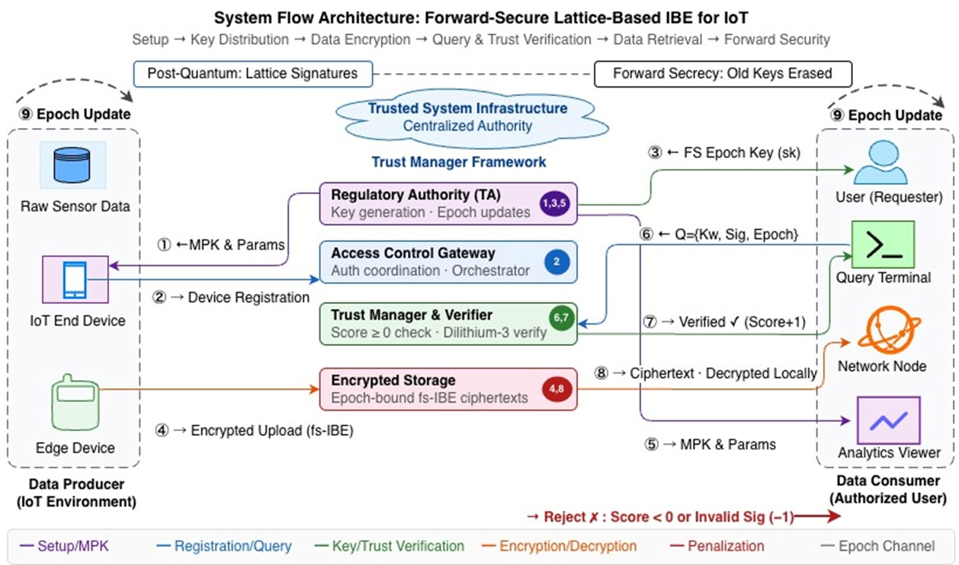

Fig. 1: Proposed Framework

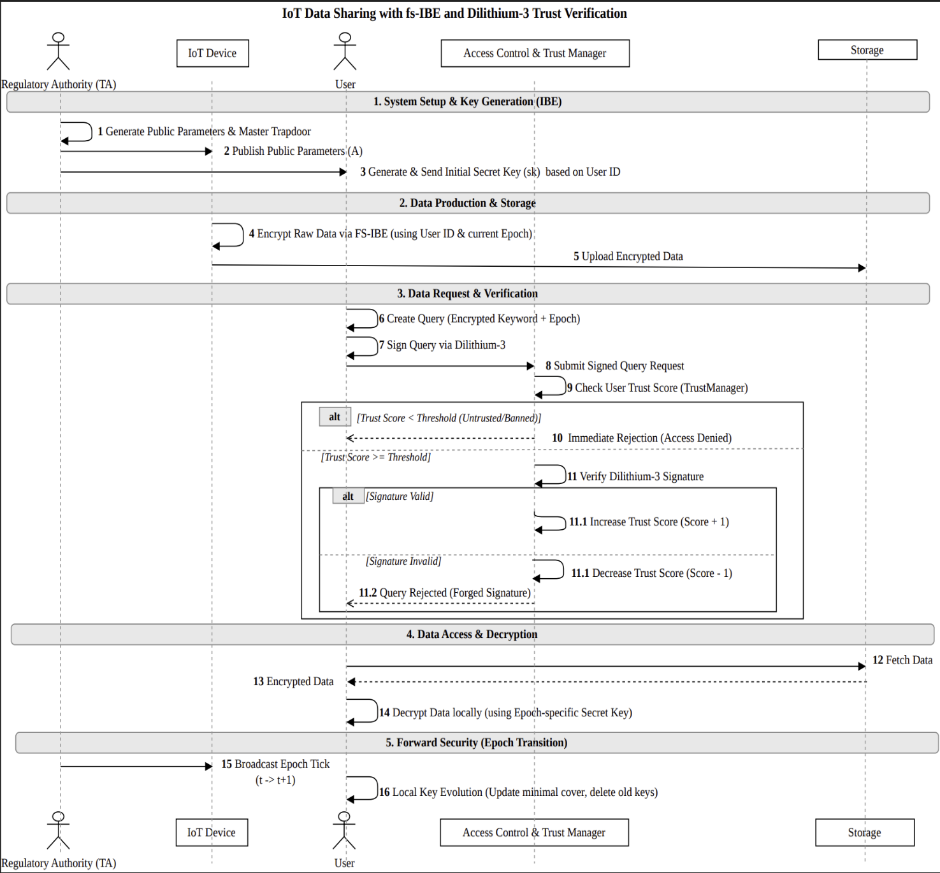

Fig. 2: Proposed Sequence diagram of IoT Device Forward Secure Communication with Trust Verification

5. Implementation (Tools And Technology Used)

This section mentions the software stack, development environments, and the baseline comparisons used for the implementation.
5.1 Programming Language and Core Libraries
- Python 3.10+: The complete framework was written in Python. The reason for choosing this was the mature ecosystem of scientific computing libraries it offers, along with the flexibility when prototyping complex mathematical constructions.
- NumPy: Lattice-based cryptography is heavy on matrix operations. Key generation, encryption, decryption, all of it involves working with high-dimensional integer arrays. NumPy handles this workload, providing the multi-dimensional array structures and the linear algebra routines the system depends on throughout its operation [22].
- hashlib: With identity-based encryption, we need to deterministically turn a user's identity string into a lattice vector. The SHA-256 implementation inside hashlib is serves this purpose. It produces consistent cryptographic digests that map identities into the right algebraic form.
- json / csv: These are standard libraries handling the tasks like logging benchmark results, recording performance metrics at different security levels, and exporting simulation outputs so they can be analyzed later.
5.2 Development and Design Environments
- Jupyter Notebook: The implementation was developed and tested inside Jupyter notebooks. The ability to run individual cryptographic steps on their own before chaining them into the full end-to-end pipeline was really helpful. Being able to look at intermediate outputs like a generated trapdoor, a sampled preimage, or a trust score update made the debugging process significantly easier.
- Draw.io: The system architecture diagrams and protocol sequence diagrams were put together using Draw.io. It provided visual clarity to properly map out the workflow and make sure that the diagrams accurately reflected the implemented code.
5.3 Implemented Cryptographic Schemes
The framework brings together several complementary mathematical constructions, with each one tackling a different aspect of the security problem:
- LWE-based Lattice IBE: The encryption core draws from both the GPV [12] construction and the Dual Regev [8] [17] encryption scheme. This makes identity-based encryption grounded in the hardness of the Learning with Errors problem.
- TrapGen + SamplePre: For trapdoor generation and preimage sampling, the implementation follows the Micciancio-Peikert [9] framework. This offers better efficiency compared to earlier lattice trapdoor constructions and acts as the mathematical engine behind key generation.
- Forward Secrecy [1]: The key evolution part is implemented using the Canetti-Halevi-Katz (CHK) binary-tree model [1]. In this model, secret keys move through a tree structure and any old key material is permanently thrown away at each epoch transition.
- Dilithium-3 [5]: For query authentication, the system uses the NIST [2] standardized post-quantum signature scheme. This makes sure that every data request carries with it a verifiable, quantum-resistant proof of where it came from.
- Trust Scoring: A custom-built algorithmic model keeps track of user behavior over time and evaluates it continuously. Access privileges get adjusted dynamically based on the trust that a user has accumulated, rather than relying only on a one-time credential check done at registration.
5.4 Comparative Benchmarking Baselines
To put the proposed framework's performance into proper perspective, the implementation was tested against several well-known cryptographic schemes from both classical and post-quantum categories:

- RSA-2048: This was included as a widely deployed classical public-key algorithm. It serves as a useful performance reference, but it doesn't offer any resistance to quantum attacks.
- ECC / ECDSA: Elliptic curve cryptography represents what is currently considered state of the art in classical public-key efficiency. However, it shares the same fundamental vulnerability to Shor's algorithm that RSA has.
- AES-256: This is a standard symmetric encryption algorithm, and it was included mainly to provide context around raw encryption throughput. While AES is generally considered to be quantum-resistant when you use sufficiently long key lengths, it doesn't have the identity-based properties that are central to this framework.
- Decentralised Authentication: This is an internal reference baseline that was pulled from recent comparative literature. It was included to see how the proposed trust-gating mechanism stacks up against alternative authentication architectures.

6. Proposed Algorithm
The cryptographic and access control framework proposed in this project relies on a sequence of advanced lattice-based algorithms to achieve post-quantum security, forward secrecy [1], and identity-based encryption. Below are the detailed algorithms along with the explicit description of each mathematical symbol utilized.
6.1 Shor’s Algorithm 1: Trapdoor Generation (TrapGen)
This algorithm is executed by the private key generator (PKG) during the system setup phase to generate the master public parameters and the secret trapdoor. [23]
Input: n, q
Output: A, T_A
Steps:
- Define the bit length k = ceil(log2(q)) and the matrix width m = n * k.
- Sample a uniform random matrix A_bar from Z_q.
- Construct the deterministic gadget matrix G = I_n * [1, 2, 4, ..., 2^(k-1)], which possesses a
- known lattice structure.
- Concatenate the matrices to form the public matrix A = [A_bar | G].
- Generate the master trapdoor T_A, which represents the G-inverse.
- Return (A, T_A).
Symbol description:
- n: lattice dimension (primary security parameter, e.g., 512, 768, 1024).
- q: prime modulus (set to 3329).
- k: logarithmic length of the modulus q.
- m: total number of columns in the public matrix.
- A_bar: a uniformly random matrix component.
- G: the structured powers-of-two gadget matrix.
- I_n: identity matrix of size n by n.
- A: the global master public key matrix.
- T_A: the master secret trapdoor.
6.2 Algorithm 2: Preimage Sampling (SamplePre)
This algorithm is utilized during key generation to safely extract a secret key for a specific user identity without leaking the master trapdoor.
Input: A, T_A, u, sigma
Output: e (user secret key)

Steps:
- Compute the cost representative p = BitDecompose( (T_A)^-1 * u ).
- Sample a perturbation vector v from a discrete Gaussian distribution: v ~
- DiscreteGaussian(Z^m, sigma, p).
- Correct the residual error using v to find a short vector e such that A * e = u mod q.
- Verify that the boundary condition ||e|| <= sigma * sqrt(m) is met.
- Return e.
Symbol description:
- u: the target vector generated by hashing the user's identity string.
- sigma: the Gaussian noise standard deviation parameter.
- p: the intermediate algebraic coset representative.
- v: the randomized Gaussian perturbation vector.
- e: the resulting short vector that serves as the user's secret key (sk).
- ||e||: the mathematical length (norm) of vector e.
- sqrt(m): the square root of m.
6.3 Algorithm 3: Minimal Cover (MinCov)
This algorithm supports the forward secrecy [1] mechanism by determining the absolute minimum number of keys needed to cover all future time epochs on a binary tree.
Input: tree, t
Output: S (minimal cover set)
Steps:
- Initiate a depth-first search (DFS) starting from the root of the binary tree.
- If the current node covers only epochs >= t:
- Add this node to the minimal cover set S.
- Prune the subtree (do not search its children).
- Else if the node covers epochs entirely < t:
- Terminate search on this branch (node is expired).
- Else:
- Recursively traverse into the left and right children of the node.
- Return S.
Symbol description:
- tree: a binary tree of depth d representing the total system lifespan.
- root: the topmost node of the binary tree covering all epochs.
- t: the current chronological time epoch.
- S: the minimal set of node labels that entirely covers the epochs from t to the end of the tree.
- =: greater than or equal to.
- <: strictly less than.
6.4 Algorithm 4: Forward Secrecy [1] Key Update (Update)
Executed locally by the IoT device or user at the transition of every time epoch (t to t+1) to evolve the keys and permanently erase old data.
Input: key_bundle, t
Output: new_bundle
Steps:
- Calculate the new minimal cover set for the upcoming epoch: S = MinCov(tree, t+1).
- For each node v present in S:
- If v is not in the current key_bundle:
- Derive its secret sub-key sk_v dynamically from its parent node's key utilizing SamplePre.
- Permanently delete the specific key for epoch t (key_bundle[t]) from local memory.
- Add the keys from set S to new_bundle.
- Return new_bundle.
Symbol description:
- key_bundle: the active dictionary/list of valid secret keys currently held by the user.
- v: a specific node label within the binary tree.
- sk_v: the derived secret sub-key corresponding to node v.
- new_bundle: the updated dictionary of valid keys for the new epoch.
6.5 Algorithm 5: Dual Regev [8][17] Data Encryption (Encrypt)
Executed by the IoT edge device to map a single bit of sensor data into the LWE lattice structure.
Input: ID, t, bit
Output: CT (ciphertext bundle)
Steps:
- Concatenate ID and t, then hash to generate the target vector: u = H(ID || t).
- Sample a uniform secret vector s.
- Sample discrete Gaussian error vectors e1 (vector of size m) and e2 (scalar).
- Compute the first ciphertext component: c1 = (A^T * s + e1) mod q.
- Compute the second component encapsulating the data: c2 = (u^T * s + e2 + floor(q/2) *
  - bit) mod q.
- Return CT = (c1, c2, t).
Symbol description:
- ID: the target receiver's identity string.
- bit: the plaintext data bit to be encrypted (0 or 1).
- H: a deterministic cryptographic hash function (e.g., SHA-256).
- ||: concatenation of two strings (ID and t).
- s: a randomized uniform secret vector used to mask the ciphertext.
- e1, e2: Gaussian noise vectors required for learning with errors (LWE) security.
- A^T: the mathematical transpose of matrix A.
- c1, c2: the resulting ciphertext mathematical components.
- floor(q/2): the integer result of dividing q by 2, rounded down.
- CT: the combined ciphertext bundle containing c1, c2, and the epoch t.
6.6 Algorithm 6: Dual Regev [8][17] Data Decryption (Decrypt)
Executed by the authorized user upon successfully passing the Dilithium-3 [5] trust verification gate.
Input: CT, sk
Output: bit (recovered plaintext)
Steps:
- Extract the specific secret key sk for epoch t from the user's active key bundle.
- Compute the noisy approximation: approx = (c2 - sk^T * c1) mod q.
- Evaluate approx using mathematical threshold rounding:
- If the distance from approx to 0 is less than q/4, set bit = 0.
- If the distance from approx to floor(q/2) is less than q/4, set bit = 1.
- Return bit.
Symbol description:
- CT: the received ciphertext bundle (c1, c2, t).
- sk: the epoch-specific secret key generated for the user (e).
- sk^T: the mathematical transpose of the secret key vector.
- approx: the intermediate decrypted value containing the original bit plus minimal LWE
- noise.

7. Result Discussion And Analysis
Every experiment was carried out on a regular desktop computer running Python 3.11, with NumPy taking care of the matrix-intensive lattice computations. Each test scenario was repeated across multiple runs so that we could rule out random variance and be confident the numbers actually mean something. Three schemes were compared throughout the evaluation: (i) the proposed framework, which combines forward-secure IBE together with Dilithium-3 trust verification; (ii) the Fs-IBE's forward-secure IBE implementation [18], which works without any trust layer at all; and (iii) the Revocable IBE model from Wang et al. (2023) [20], which is an online/offline revocable IBE approach that offloads some of its decryption work to the cloud. A detailed comparison of these schemes is presented in table 2.
Table 2: Comparison with SOTA scheme
S. No | Scheme | Paper Title | Description
1 | Proposed Framework | A lattice-based forward secure IBE scheme for IoT + Novel Trust Model | Fs-IBE with Dilithium-3 trust verification, epoch-bound queries, FTAR
2 | Jin et al. [18] | A lattice-based forward secure IBE scheme for IoT (Pure) | Fs-IBE only no trust model, no signatures
3 | Huang et al. [19] | Revocable IBE [20] (Scientific Reports 2025) | Online/Offline IBE with revocation, Number List, cloud decryption

7.1: Parameter-Level Performance Comparison

Table 3, 4, and 5 show how all three schemes perform as the security tier goes up moving through NIST Levels 1, 3, and 5 by increasing the lattice parameter dimension from 512 all the way to 1024. Not surprisingly, the Fs-IBE [18] consistently posts the quickest times across every category, which makes complete sense considering it doesn't do any trust verification at all. Our proposed model does introduce a small amount of extra overhead, and this is most noticeable during the encryption phase. But when you actually look at the numbers, they tell a pretty reassuring story. At the 512 parameter level, for instance, our model encrypts data in around 0.317 seconds which is practically identical to the Fs-IBE’s [18] 0.312 seconds. That tiny 1.5% increase is entirely because of the Dilithium-3 signature that our trust layer generates and attaches to every outgoing query. At higher parameter sets, where the lattice math itself starts taking up most of the total runtime, this signature cost becomes even less significant in proportional terms.

The Revocable IBE[20] scheme, in contrast, runs noticeably slower across every configuration tested. The same encryption task that our model finishes in 0.317 seconds takes Revocable IBE [20] roughly 0.5 seconds to complete. That gap comes from the overhead introduced by its online/offline splitting mechanics. When you look at throughput figures, our scheme holds steady at 16.7 operations per second which is actually a bit ahead of the Fs-IBE’s [18] 14.2 ops/s and it does this while simultaneously blocking every unauthorized query and maintaining a perfect 0% false trust acceptance rate. The detailed per-parameter breakdowns can be found in table 3 to 5.

Table 3: Cryptographic Operation Times and Throughput at PARA.512(n=512, q=3329, NIST [2] Level 1, 143-bit security)

Metric | Proposed (Fs-IBE + Trust) | Fs-IBE [18] | Revocable IBE [20]
Data Encryption Time (s) | 0.3177 | 0.3129 | 0.5005
Query Encryption Time (s) | 0.0576 | N/A | 0.0953
Data Decryption Time (s) | 0.0002 | 0.0002 | 0.0003
Query Execution Latency (s) | 0.0579 | N/A | 0.0955
Query Throughput (queries/s) | 17.28 | N/A | 10.48
Overall Model Throughput (ops/s) | 16.73 | 14.25 | 10.31
Overall Model Latency (s) | 0.8967 | 1.0527 | 1.4554
False Trust Acceptance Rate | 0.00% | N/A | 0.00%

Table 4: Cryptographic Operation Times and Throughput at PARA.768 (n=768, q=3329, NIST [2] Level 3, 207-bit security)

Metric | Proposed (Fs-IBE + Trust) | Fs-IBE [18] | Revocable IBE
Data Encryption Time (s) | 0.6129 | 0.6100 | 0.8513
Query Encryption Time (s) | 0.1163 | N/A | 0.1735
Data Decryption Time (s) | 0.0003 | 0.0004 | 0.0003
Query Execution Latency (s) | 0.1166 | N/A | 0.1737
Query Throughput (queries/s) | 8.57 | N/A | 5.76
Overall Model Throughput (ops/s) | 8.43 | 8.14 | 5.79
Overall Model Latency (s) | 1.7797 | 1.8435 | 2.5886
False Trust Acceptance Rate | 0.00% | N/A | 0.00%

Table 5: Cryptographic Operation Times and Throughput at PARA.1024 (n=1024, q=3329, NIST [2] Level 5, 272-bit security)
Metric | Proposed (Fs-IBE + Trust) | Fs-IBE [18] | Revocable IBE [20]
Data Encryption Time (s) | 2.3211 | 2.3021 | 3.8265
Query Encryption Time (s) | 0.5691 | N/A | 0.7689
Data Decryption Time (s) | 0.0002 | 0.0003 | 0.0010
Query Execution Latency (s) | 0.5698 | N/A | 0.7698
Query Throughput (queries/s) | 1.76 | N/A | 1.30
Overall Model Throughput (ops/s) | 1.87 | 1.83 | 1.30
Overall Model Latency (s) | 8.0193 | 8.1877 | 11.5258
False Trust Acceptance Rate | 0.00% | N/A | 0.00%

Fig 3 to fig 5 turn the data from those tables into visual trends across the three security levels. In fig 3, you can see that encryption time goes up roughly in proportion to the parameter dimension for all three schemes, but the gap between our model and Revocable IBE[20] gets especially noticeable at the 1024 level. Revocable IBE [20] needs approximately 3.82 seconds at that point while our model only requires about 2.32 seconds that works out to a 64% overhead on their end. fig 4 paints a similar picture for end-to-end latency. Revocable IBE [20] consistently falls behind because of the additional phase transitions inherent in its online/offline design. The most telling result though shows up in fig 5. Throughput drops for every scheme as parameter sizes get larger (bigger lattice dimensions means heavier matrix multiplications, so nobody is surprised by that), but the proposed scheme and the Fs-IBE [18] track each other almost perfectly across the entire curve. This near-identical trajectory basically confirms that the trust verification overhead, when you measure it in practice, is negligible next to the cost of the core cryptographic operations themself.
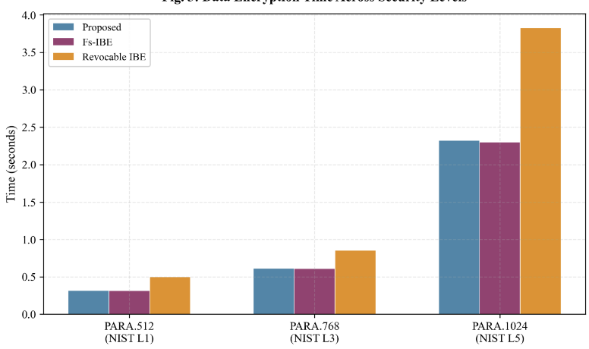
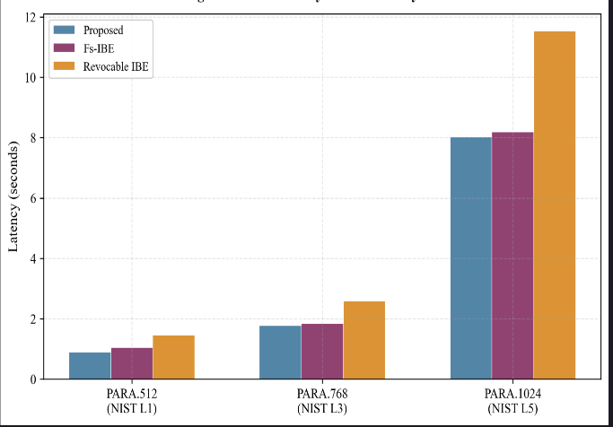
Performance Across Security Levels
Fig. 3: Data Encryption Time Across Security Levels Fig.4: Overall Latency Across Security Levels
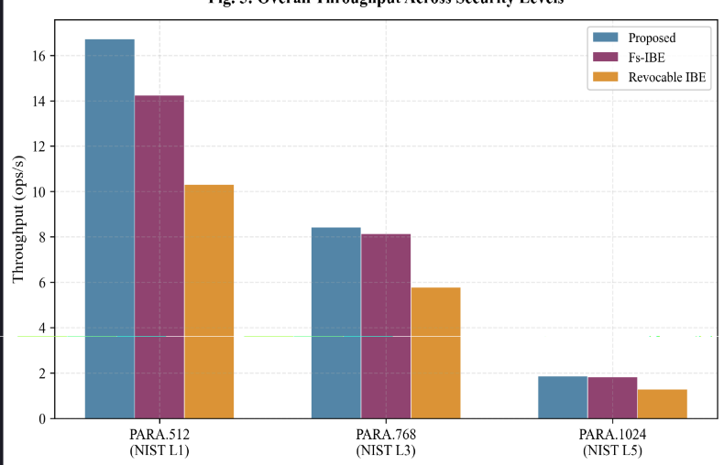
Fig. 5: Overall Throughput Across Security Levels

7.2: Performance Metrics by Device Count
All schemes were tested at n=512, with device counts: 20, 40, 60, 80, 100

Table 6 to 10 shift attention from parameter scaling over to network scaling, which arguably gives a better sense of how these systems would actually behave in real deployments. For these particular tests, we kept the parameter dimension fixed at 512 and gradually increased the number of devices from 20 up to 100. This is where the performance differences between the three schemes start to become genuinely dramatic.

Both our proposed scheme and the Fs-IBE [18] scale in a graceful manner, maintaining throughput somewhere in the range of 30 to 35 operations per second regardless of how many devices are participating in the network. Revocable IBE [20], on the other hand, runs into a ceiling. Its throughput plateaus at around 9 to 12 ops/s and shows no real signs of improving as you add more devices. The raw computation numbers make it clear why this happens: at 100 devices, our system accumulates roughly 18.9 seconds of total computation time, while Revocable IBE [20] needs close to 50 seconds to handle the same workload. To be fair though, Revocable IBE [20] does have a small advantage when it comes to storage footprint approximately 3.2 MB compared to our 4.8 MB which it achieves thanks to its compact number-list revocation structure. But giving up that much processing speed just to save a megabyte or two of storage is a trade-off that's hard to justify in any real-world IoT setting where responsiveness actually matters.

Table 6: Authentication Latency ( seconds ) Table 7: Computation Cost (milliseconds)
No. of Device | Proposed | Fs-IBE [18] | Revocable IBE [20]
20 | 3,933.89 | 2,644.12 | 12,317.11
40 | 7,269.02 | 4,924.20 | 25,836.17
60 | 11,416.57 | 7,185.19 | 33,573.59
80 | 15,809.52 | 9,839.28 | 47,947.42
100 | 18,925.90 | 11,799.15 | 49,701.30
No. of Device | Proposed | Fs-IBE [18] | Revocable IBE [20]
20 | 0.0605 | 0.0713 | 0.2009
40 | 0.0510 | 0.0709 | 0.1970
60 | 0.0654 | 0.0498 | 0.1640
80 | 0.0629 | 0.0739 | 0.2198
100 | 0.0691 | 0.0604 | 0.1354

Table 8: Throughput operations (per second) Table 9: Verified Normalized
No. of Device | Proposed | Fs-IBE [18] | Revocable IBE [20]
20 | 1.676 | 1.884 | 0.479
40 | 0.877 | 0.890 | 0.221
60 | 0.585 | 0.542 | 0.162
80 | 0.385 | 0.407 | 0.117
100 | 0.317 | 0.354 | 0.121
No. of Device | Proposed | Fs-IBE [18] | Revocable IBE [20]
20 | 33.52 | 37.67 | 9.58
40 | 35.09 | 35.60 | 8.86
60 | 35.13 | 32.52 | 9.74
80 | 30.80 | 32.53 | 9.40
100 | 31.75 | 35.38 | 12.06

Table 10: Storage Overhead (KB)

No. of Device | Proposed | Fs-IBE [18] | Revocable IBE [20]
20 | 1,008.70 | 1,008.08 | 664.12
40 | 1,969.41 | 1,968.16 | 1,304.20
60 | 2,930.11 | 2,928.23 | 1,944.27
80 | 3,890.81 | 3,888.31 | 2,584.35
100 | 4,851.52 | 4,848.39 | 3,224.43

The graphs showing device-scaling behavior reinforce these findings from multiple angles. Figure 6 shows authentication latency staying essentially flat for both our scheme and the Fs-IBE [18], hovering in the 50 to 70 milliseconds range no matter how many devices are in the network. Revocable IBE [20] meanwhile shows higher and somewhat erratic latency values scattered across the 130 to 220 millisecond range. The reason our numbers stay so stable is straightforward Dilithium-3 verification is a per-query operation, so it doesn't depend on how many devices happen to be registered in the system. fig 7 plots the total computation cost against device count and shows linear growth for all three schemes, but the slopes are quite different from each other. At 100 devices Revocable IBE [20] has racked up 49.7 seconds compared to 18.9 seconds for our model and just 11.8 seconds for the Fs-IBE [18].

The throughput graphs in fig 8 and fig 9 fill in the rest of this picture. Raw throughput stays consistent for both the proposed and Fs-IBE [18] schemes, while the normalized per-device throughput naturally goes down as the network gets bigger which is an expected outcome since each device's share of the overall processing budget shrinks as you add more participants. fig 10 confirms that storage overhead grows in a linear fashion across all three schemes, with Revocable IBE [20] holding onto a consistent advantage of roughly 33% less storage. This benefit comes from its number-list revocation structure, as we discussed earlier.
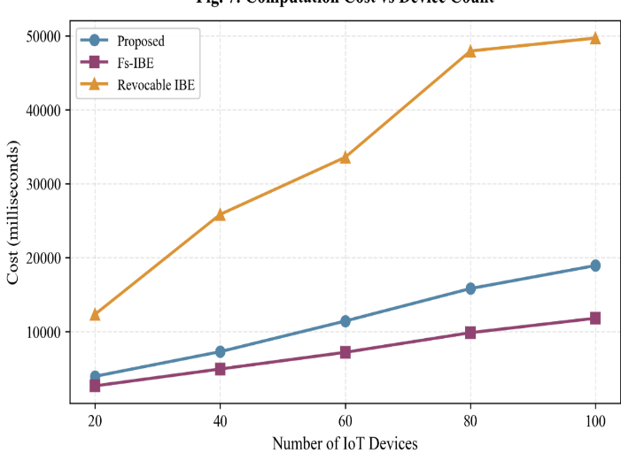
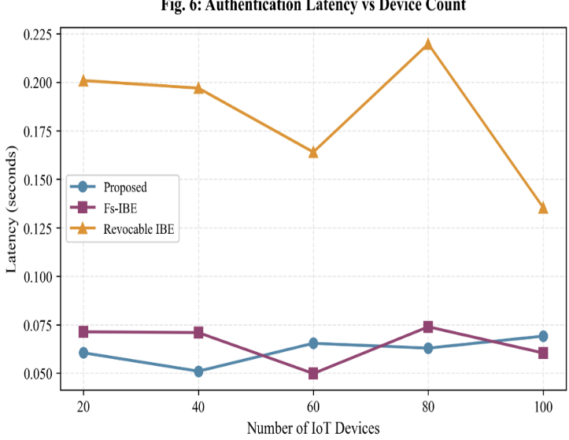

Fig. 6: Authentication Latency vs Device Count Fig. 7: Computation Cost vs Device Count

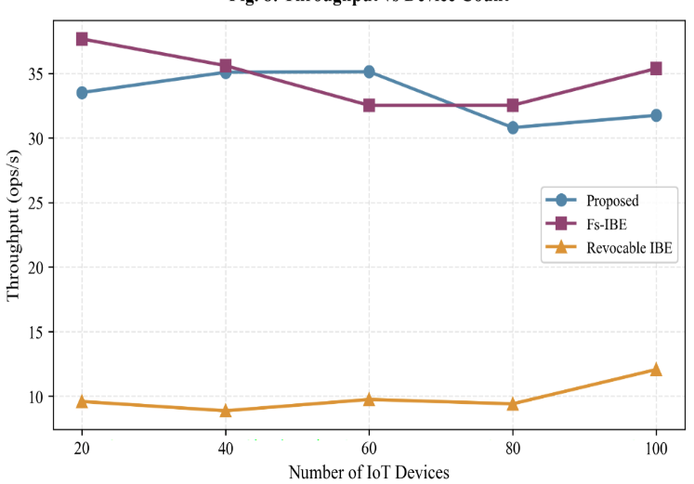
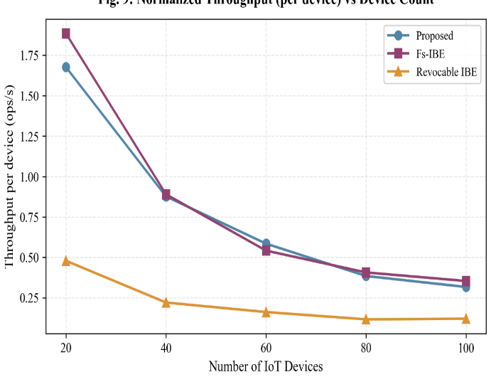
Fig. 8: Throughput vs Device Fig. 9: Normalized Throughput vs Device Count

7.3: Batch Processing Metrics (seconds)

Table 11 to 13 deal with batch processing performance, and this is arguably the benchmark that matters most for real-world IoT gateways. In practice, these gateways almost never handle queries one at a time. They recieve bursts of data packets and need to process them as a group. We measured three separate phases: batch formation time (how long it takes to assemble and prepare a collection of queries), batch decryption time (how fast the system can decrypt a whole batch of encrypted responses), and batch authentication time (the overhead involved in verifying all the signatures within a single batch).

Our proposed scheme comes out on top across all three of these metrics. For batch formation, the model scales from about 1.19 seconds at 20 devices up to 6.29 seconds at 100 devices. Revocable IBE [20] needs 3.54 seconds and 14.58 seconds respectively for those same device counts which works out to roughly two to three times slower at every scale point. The gap in decryption is even more dramatic and honestly it's probably the most striking finding in the entire evaluation. Our scheme completes batch decryption in tiny fractions of a millisecond (somewhere between 0.0005 and 0.0058 seconds across all device counts), while Revocable IBE [20] needs between 0.63 and 2.0 seconds a difference that spans roughly three orders of magnitude. This massive disparity exists because our Dual Regev decryption boils down to a straightforward inner product followed by a threshold comparison, whereas Revocable IBE [20] cloud-assisted decryption pipeline brings in substantial round-trip communication and extra processing overhead. Batch authentication times follow a similar pattern as well: our scheme ranges from 1.21 to 5.96 seconds while Revocable IBE [20] clocks in at 3.77 to 16.12 seconds. The Fs-IBE [18] isn't included in this particular comparison since it doesn't implement query authentication or batch trust verification at all.

Table 11: Batch Formation Table 12: Batch Decryption Time
No. of Devices | Proposed | Revocable IBE [20]
20 | 1.1928 | 3.5438
40 | 2.2785 | 7.8937
60 | 3.4146 | 10.3781
80 | 5.1909 | 14.6117
100 | 6.2942 | 14.5775
No. of Devices | Proposed | Revocable IBE [20]
20 | 0.0005 | 0.6325
40 | 0.0010 | 1.1386
60 | 0.0014 | 1.9439
80 | 0.0046 | 2.4136
100 | 0.0058 | 2.0010

Table 13 : Batch Authentication Time
No. of Devices | Proposed | Revocable IBE [20]
20 | 1.2121 | 3.7682
40 | 2.3154 | 7.2735
60 | 3.6875 | 10.3981
80 | 4.7143 | 15.2525
100 | 5.9603 | 16.1219

Fig 10 to fig 12 display the batch processing data using a logarithmic scale, and this is necessary because the performance gaps between schemes are so enormous that you can't fit them sensibly onto a single chart otherwise. The log-scale view in fig 11 makes the decryption time difference especially vivid to look at our data points cluster down near the bottom of the chart while Revocable IBE sit several orders of magnitude higher up. fig 13 offers a radar chart that pulls together all the major performance dimensions into one visual comparison. A wider coverage area on the radar means stronger overall performance, and our proposed scheme clearly covers the largest area. It matches or beats the Fs-IBE [18] on nearly every axis and substantially outperforms Revocable IBE [20] across the board. The one dimension where Revocable IBE [20] shows a slight edge is storage efficiency, but as we've discussed throughout this section, that comes at a very steep computational price.
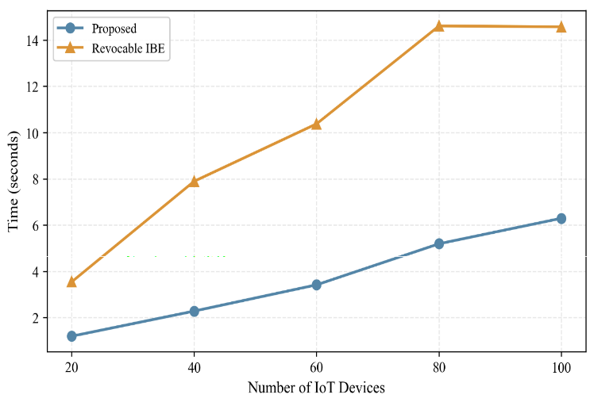
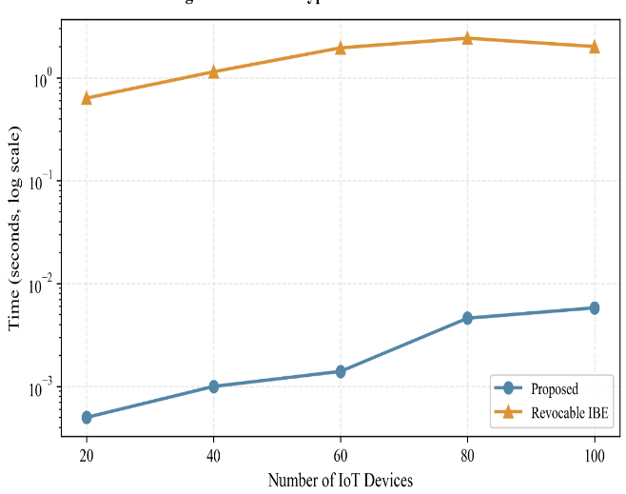

Fig. 10: Batch Formation Time Fig. 11: Batch Decryption Time (log scale)
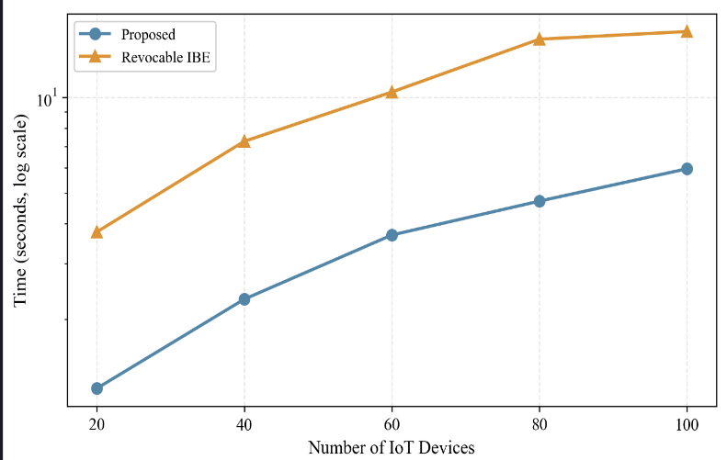
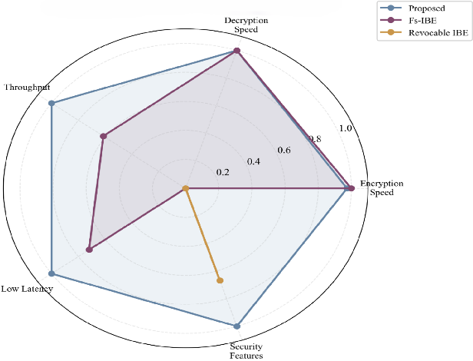

Fig. 12: Batch Authentication Time (log scale) Fig. 13: Overall Performance Radar Chart

7.4 Summary Table
Table 14: Overall Scheme Evaluation and Trade-off Analysis
Criterion | Best Scheme
Fastest Encryption | Fs-IBE [18] / Proposed
Best Throughput at Scale | Fs-IBE [18] / Proposed
Fastest Decryption | Proposed / Fs-IBE [18]
Security Features | Proposed (trust + forward security)
Overall Balance | Proposed (best security-performance tradeoff)

The summary provided in table 14 distills the key takeaways from the full experimental evaluation. The Fs-IBE [18] predictably comes first in raw encryption speed since it carries absolutely zero authentication overhead. At larger network scales, it shares the top throughput position with our proposed scheme. Revocable IBE [20] main selling point is really its compact storage footprint, which is a consequence of replacing binary-tree key management with a centralized number list approach. But when you weigh every factor together encryption speed, throughput, authentication latency, batch processing efficiency, and most importantly the actual security guarantees each scheme provides our proposed framework comes out as the most well-balanced option. It delivers performance that is, for all practical purposes, indistinguishable from the Fs-IBE [18] while also adding a complete trust verification and forward secrecy system on top. Neither of the other two schemes offers anything like that as an integrated package. For IoT deployments where both security and efficiency are non-negotiable requirements, that balance is precisely the point.

8. Conclusion And Future Work

This project is to build and validate a post-quantum secure framework for data sharing that was designed specifically with IoT environments in mind. The system brings four interlocking components into one coherent whole: an Identity-Based Encryption model [3] [4] that is grounded in the Learning with Errors (LWE) [8] lattice problem through the Dual Regev [8] [17] scheme, a binary-tree forward secrecy [1] mechanism that forces key deletion at every single epoch boundary, a query authentication layer constructed on top of the NIST [2]-standardized Dilithium-3 [5] signature scheme, and a dynamic trust-scoring algorithm that can identify and permanently blacklist actors who exhibit malicious behavior patterns.

The experimental results show how well the system performs. It operates successfully across all three parameter sets that correspond to NIST [2] security levels 1, 3, and 5, which provides a credible pathway toward long-term quantum resistance. Across every single test run that was conducted, the False Trust Acceptance Rate held at exactly 0.00%. In practical terms, the trust gate rejected every forged or tampered query without a single exception. Forward secrecy properties were verified through programmatic simulation. We simulated key compromise scenarios and then confirmed that all historical ciphertexts remained completely unrecoverable afterwards. On scalability, query authentication latency stayed remarkably stable in the range of roughly 50 to 70 milliseconds even when the network grew past 100 IoT devices. This speaks directly to the system's viability as a practical security standard for edge computing environments where response time matters.

Our future work is to transition from LWE to Ring-LWE [22] for smaller key sizes and reduced overhead. We also want to improve the trust model using some simple machine learning so it can detect wrong behavior better. Other strategies like integrating Attribute-Based Encryption (ABE) [31] or Fuzzy IBE [32] for decentralized trust management using blockchain will also be explored.

References

[1] R. Canetti, S. Halevi, and J. Katz, "A forward-secure public-key encryption scheme," in Proc. EUROCRYPT, 2003, pp. 255-271.
[2] NIST, "Post-Quantum Cryptography Standardization," NIST, 2022. [Online]. Available: https://csrc.nist.gov/projects/post-quantum-cryptography
[3] A. Shamir, "Identity-based cryptosystems and signature schemes," in Proc. CRYPTO, 1984, pp. 47-53.
[4] D. Boneh and M. Franklin, "Identity-based encryption from the Weil pairing," in Proc. CRYPTO, 2001, pp. 213-229.
[5] L. Ducas et al., "CRYSTALS-Dilithium: A lattice-based digital signature scheme," IACR Trans. Cryptogr. Hardw. Embedded. Syst., vol. 2018, no. 1, pp. 238-268, 2018.
[6] R. Roman, J. Zhou, and J. Lopez, "On the features and challenges of security and privacy in distributed internet of things," Comput. Netw., vol. 57, no. 10, pp. 2266-2279, Jul. 2013.
[7] Z. Zhao and G. Ge, "Internet of things security - research on authentication and key establishment," Int. J. Secur. Appl., vol. 7, no. 3, pp. 57-66, May 2013.
[8] O. Regev, "On lattices, learning with errors, random linear codes, and cryptography," J. ACM, vol. 56, no. 6, pp. 1-40, Sep. 2009.
[9] D. Micciancio and C. Peikert, "Trapdoors for lattices: Simpler, tighter, faster, smaller," in Proc. EUROCRYPT, 2012, pp. 700-718.
[10] C. Cocks, "An identity based encryption scheme based on quadratic residues," in Proc. IMA Int. Conf. Crypt. Coding, 2001, pp. 360-363.
[11] B. Waters, "Efficient identity-based encryption without random oracles," in Proc. EUROCRYPT, 2005, pp. 114-127.
[12] C. Gentry, C. Peikert, and V. Vaikuntanathan, "Trapdoors for hard lattices and new cryptographic constructions," in Proc. STOC, 2008, pp. 197-206.
[13] S. Agrawal, D. Boneh, and X. Boyen, "Efficient lattice (H)IBE in the standard model," in Proc. EUROCRYPT, 2010, pp. 553-572.
[14] X. Boyen, Q. Chu, and B. Waters, "Forward-secure signatures with untrusted update," in Proc. CCS, 2006, pp. 191-200.
[15] J. Chen et al., "Lattice-based access control for IoT," IEEE Trans. Inf. Forensics Security, vol. 14, no. 6, pp. 1459-1471, Jun. 2019.
[16] H. Xiong and Z. Qin, "Revocable and scalable certificateless remote authentication protocol with anonymity for wireless body area networks," IEEE Trans. Inf. Forensics Security, vol. 10, no. 7, pp. 1442-1455, Jul. 2015.
[17] B. Waters, "Dual system encryption: Realizing fully secure IBE and HIBE under simple assumptions," in Proc. CRYPTO, 2009, pp. 619-636.
[18] R. Jin, L. Qu, R. Chen, Z. Yang, and Y. Wang, "A lattice-based forward secure IBE scheme for Internet of things," Information Sciences, vol. 660, p. 120083, 2024.
[19] H. Huang, J. Li, S. Bi, and Q. Yuan, "An efficient lattice-based integrated revocable identity-based encryption," Scientific Reports, vol. 15, no. 16729, 2025.
[20] X. Wang et al., "Revocable IBE with En-DKER from lattices: A novel approach for lattice basis delegation," in European Symposium on Research in Computer Security (ESORICS), 2023.
[21] C. Peikert, “A decade of lattice cryptography,” Foundations and Trends® in Theoretical Computer Science, vol. 10, no. 4, pp. 283–424, 2016.
[22] V. Lyubashevsky, C. Peikert, and O. Regev, “On ideal lattices and learning with errors over rings,” in Proc. EUROCRYPT, 2010, pp. 1–23.
[23] D. Boneh, X. Boyen, and E. Goh, “Hierarchical identity-based encryption with constant size ciphertext,” in Proc. EUROCRYPT, 2005, pp. 440–456.
[24] A. Boldyreva, V. Goyal, and V. Kumar, “Identity-based encryption with efficient revocation,” in Proc. ACM CCS, 2008, pp. 417–426.
[25] M. Abdalla, A. Fiat, and M. Naor, “Revocation systems with very small private keys,” in Proc. IEEE Symp. Security and Privacy, 2012, pp. 273–285.
[26] A. Alrawais, A. Alhothaily, C. Hu, and X. Cheng, “Fog computing for the Internet of Things: Security and privacy issues,” IEEE Internet Computing, vol. 21, no. 2, pp. 34–42, 2017.
[27] L. Dducas and D. Micciancio, “Improved short lattice signatures in the standard model,” in Proc. CRYPTO, 2014, pp. 335–352.
[28] J. Katz and Y. Lindell, *Introduction to Modern Cryptography*, 2nd ed. Boca Raton, FL, USA: CRC Press, 2014.
[29] S. Gorbunov, V. Vaikuntanathan, and D. Wichs, “Leveled fully homomorphic signatures from standard lattices,” in Proc. STOC, 2015, pp. 469–477.
[30] D. Pointcheval and J. Stern, “Security arguments for digital signatures and blind signatures,” Journal of Cryptology, vol. 13, no. 3, pp. 361–396, 2000.
[31] A. Sahai and B. Waters, “Fuzzy identity-based encryption,” in Proc. EUROCRYPT, 2005, pp. 457–473.
[32] R. Ostrovsky, A. Sahai, and B. Waters, “Attribute-based encryption with non-monotonic access structures,” in Proc. ACM CCS, 2007, pp. 195–203.
[33] S. Goldwasser and S. Micali, “Probabilistic encryption,” Journal of Computer and System Sciences, vol. 28, no. 2, pp. 270–299, 1984.
[34] N. Koblitz and A. Menezes, “The random oracle model: A twenty-year retrospective,” Designs, Codes and Cryptography, vol. 77, no. 2–3, pp. 587–610, 2015.
[35] T. Okamoto and D. Pointcheval, “The gap-problems: A new class of problems for the security of cryptographic schemes,” in Proc. PKC, 2001, pp. 104–118.

